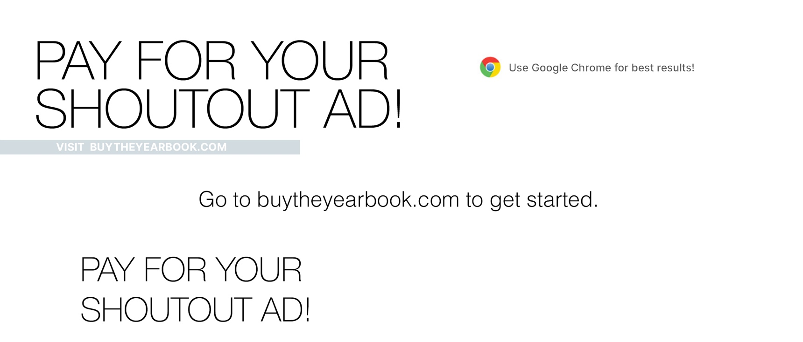

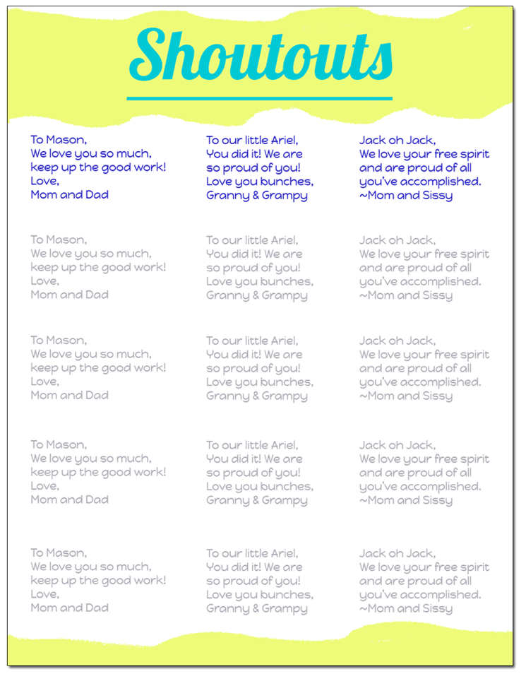
THIS IS FOR PAYMENT ONLY.

You must email your message to
.​
Please note there is a 100-character limit
(including spaces).

• Go to buytheyearbook.com
• Find your school by state/city or
school ID ( ) then click “Let’s Go!”
• Click on “ADS”
• Fill in first/last name and grade in
the corresponding fields
• Click on “ADD TO CART”
• Select “Go to Cart” to pay for your
Shoutout Ad or “Continue Shopping”

IMPORTANT:
Once your payment is complete, please email your shoutout dedication to .
Please note there is a 100-character limit (including space), per shoutout.​

If you have questions or need assistance, call us at 1-800-290-0036.

